**Find the optimal path for the lift**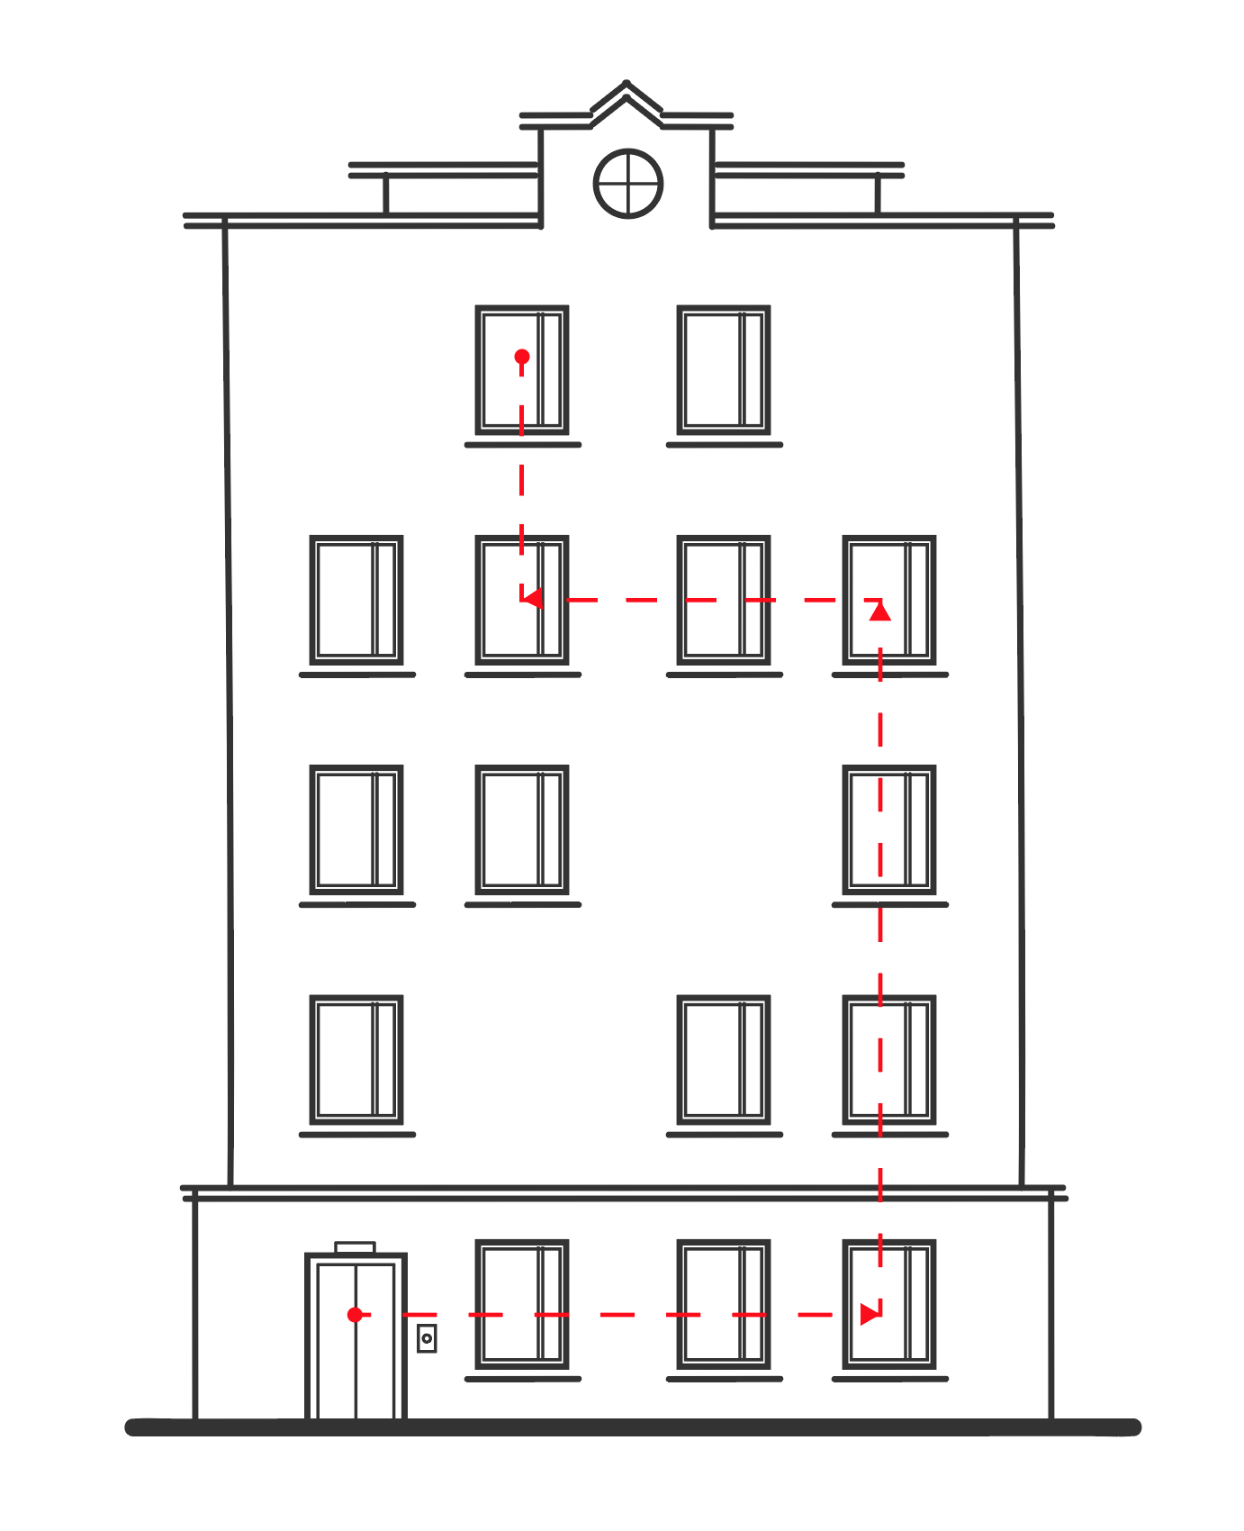

In this building, the lift can go to any apartment. Find the optimal path for the lift, taking into account that the time needed to pass through an apartment varies.

Apartments and floors are numbered from the left bottom corner of the building, starting with 0.

**Input:**

A matrix T with N*M elements specifying the time it takes for the lift to pass through an apartment. T[i,j] equals 0 means that there is no way through that apartment [i,j].

**Output:**

Link to a Сodesandbox project with

- a building HTML layout

- input fields for floor/apartment

- a GO! button to start lift movement

- window.solve function that solves the task

Lift movement should be animated proportionally to the time needed to pass through an apartment.

Please fork the project starter from <https://codesandbox.io/s/6n2j5pw0nk>.

You are welcome to use any framework or library.

**Constraints:**

0 < N, M <= 100

0 <= T[i, j] <= 5000

**Example**:

const A = [

[100, 210, 200],

[300, 0, 40],

[91, 50, 20]

]

Current lift position: 0, 0 (value 91)

Input: Move lift to floor 2 flat 1 (value 210)

Expected lift movement:

[[0, 1], [0, 2], [1, 2], [2, 2], [2, 1]], total time 520 (=50+20+40+200+210)

**Solution evaluation criteria**:

- Code quality

- Visual appearance

- Implementation conciseness and simplicity

Please, send us your solutions to [front-end-challenge@grammarly.com](mailto:front-end-challenge@grammarly.com) by November 24, 1:00 PM.

If you have any questions, feel free to contact us at [front-end-challenge@grammarly.com](mailto:front-end-challenge@grammarly.com).